GOLDEN VALLEY GROUPS INITIATIVE

A simple project, focused on improving Communication, which attempts to:
make people more aware of their local ‘Community Groups’ (those who help others to enjoy their lives more or generally survive Life a bit more easily),
make it easier for those groups to be more aware of each other, and
encourage those groups to Co-operate with each other, to Co-ordinate some of their activities and perhaps even to Collaborate on some events.

 | Not all crossings have to be fantastic structures in order to get the job done and make a difference. We hope to build some bridges but sometimes everyone will be happy with just a plank. | 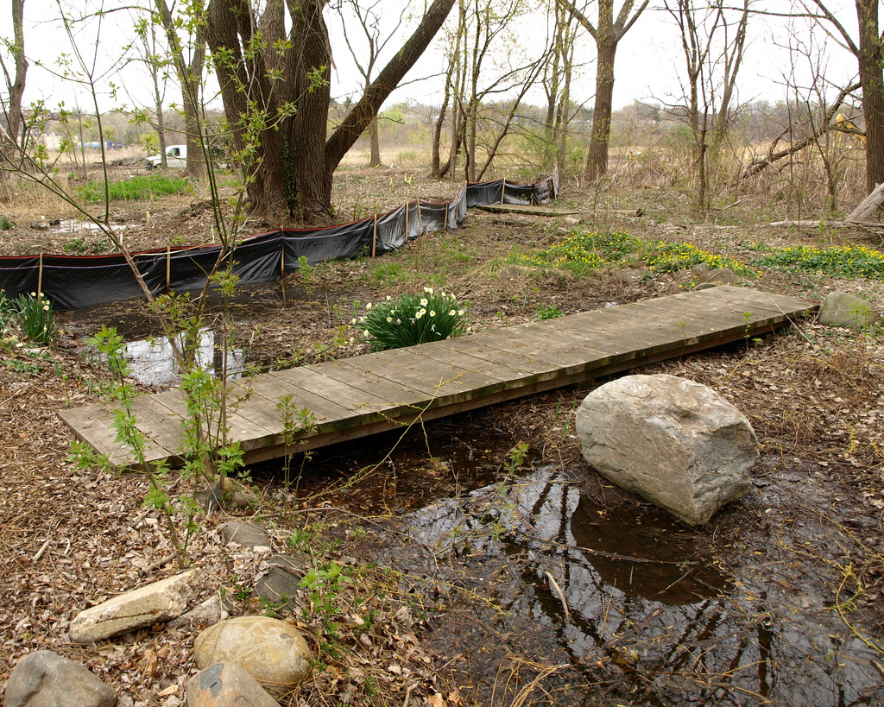

Illiteration sometimes Inspires us. In our web site we talk about Connection then Communication and, hopefully,
Co-operation, Co-ordination and Collaboration. We also like Care, Commitment & Compassion and sometimes we aim to Persuade through Pragmatism, Perseverance & Patience. Perhaps there is a Punch-line Coming. Perhaps not.
[Although it is rare for us to be so PC.]

www.GoldenValleyGroups.UK

